Email: deeprastogi99@gmail.com
Deep Rastogi
Mobile: (+91) 8468854100

Cultivate a strong background as a Java Analyst Developer with extensive experience in software development and analytical roles across various industries, targeting to leverage extensive technical expertise in leading innovative projects within the technology sector.

PROFILE SUMMARY
- Accomplished Senior Java Analyst Developer with 10+ years of progressive experience designing, architecting, and delivering enterprise-grade, three-tier and microservices-based applications across telecom, automotive, semiconductor, defense, and IT services domains.
- Proven expertise in building scalable, high-performance applications using Java/JEE, Spring Boot, Spring MVC, Hibernate, JMS, RESTful services, and modern web technologies, with deep command over MVC architecture and distributed system design.
- Showcased capability in leading full-stack development initiatives from business requirement analysis, solution architecture, data modeling, and framework selection to deployment, integration, and production stabilization.
- Strong background in enterprise modernization initiatives including migration to Spring Boot microservices architecture, secure authentication frameworks, real-time engine implementation, and system optimization for high-availability environments.
- Hands-on technical leader with extensive experience collaborating with global stakeholders across organizations such as Publicis Sapient, Cignex Datamatics, Fujitsu Consulting India, DRDO (ISSA), Wipro, Stellantis, and StMicroelectronics, delivering mission-critical systems and strategic internal platforms.
- Competent at designing domain-driven solutions including workflow engines, simulation engines, entity management systems, and enterprise collaboration platforms, ensuring alignment between technical architecture and business objectives.

CORE COMPETENCIES

 | Enterprise Application Architecture  |  | Spring Boot & Spring MVC Framework Expertise |  | Java/JEE /React Js Full Stack Development
 | Hibernate & ORM-Based Data Persistence |  | Microservices Design & RESTful API Development |  | System Integration & JMS-Based Messaging
 | Secure Application Development  |  | Database Design, Data Modeling & Performance Tuning |  | Workflow & Simulation Engine Development
SOFT SKILLS EDUCATION
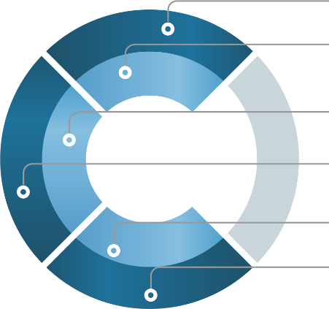
Strategic Communication Analytical
 | Master of Computer Application from Gautam Buddh Technical University, Uttar Pradesh, INDIA (2009-2012)
 | Bachelor of Science with Mathematics & Physics from Mahatma Jyotiba Phule Rohilkhand University, Uttar Pradesh, INDIA (2006-2009)

Critical Thinking

Detail Oriented

Problem Solving Leadership & Mentorship

IT SKILLS
- Java/JEE, JSP, Servlets | Spring IOC/WebFlow MVC | Hibernate | MySQL
| HTML5/CSS3 | XML, JSON, AJAX | Spring Boot | Git, Ant | Apache Tomcat, JBoss | Junit | SQL, | Windows, Eclipse, NetBeans | AWS | GraphQL | Rest API |React Js


CAREER TIMELINE (Recent Four)

Java Developer

Software Developer

Senior Software Developer

Senior Associate Technology L2


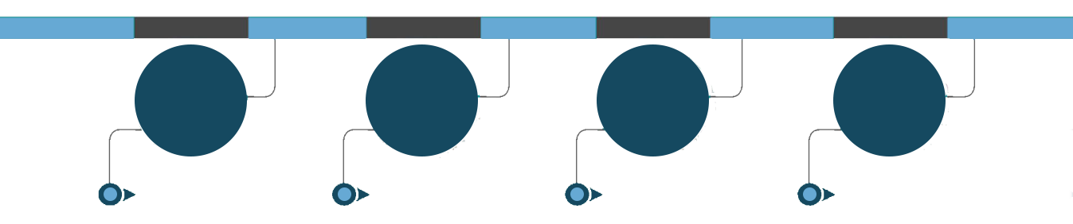
2015 - 2016
2016 - 2019
2019 - 2024
Since 2024

NOTABLE ACCOMPLISHMENTS ACROSS CAREER
- Spearheaded the development of a web application that improved operational efficiency reducing processing time for internal requests.
- Achieved an increase in user engagement and satisfaction through the successful launch of a high-impact web application.
- Enhanced application security, leading to a decrease in vulnerabilities identified during security audits.
- Improved team productivity by implementing agile practices, resulting in an increase in project delivery speed.
- Developed a comprehensive training program for new hires, enhancing onboarding efficiency and reducing ramp-up time.


WORK EXPERIENCE
Senior Associate Technology L2 | Publicis Sapient | October 2024 – Present
Deployment: Stellantis, Noida
Project: Omantel Engagement
Technology Stack: Java 8, JEE,,React Js, Spring Boot (Microservices), Spring MVC, Hibernate, AWS, PostgreSQL, JMS, REST/JSON, JSP/Servlets, jQuery, AJAX, Apache Tomcat, Linux, Oracle, SVN, ClearCase  Leading the development and enhancement of a three-tier enterprise web
application platform designed to streamline multi-level request handling and workflow orchestration across Stellantis business units.
- Architecting and implementing Spring Boot–based microservices to modernize legacy components and improve scalability, maintainability, and deployment flexibility.
- Designing and optimizing backend modules using Hibernate ORM and PostgreSQL, ensuring high-performance data transactions and robust persistence management.
- Developing workflow-driven engines that support strategic decision-making processes and cross-functional team collaboration within the Stellantis operational ecosystem.
- Contributing to system integration using JMS-based messaging to enable seamless inter-module communication across distributed components.
- Ensuring code quality, production stability, and performance optimization through structured development practices and adherence to enterprise standards.
- Collaborating with client stakeholders and cross-functional teams to translate business requirements into scalable technical solutions aligned with long-term architectural goals.
Senior Software Developer | Cignex Datamatics | March 2019 – September 2024
Deployed at: Wipro, Noida
Project: FIPC & TBA Platforms
Technology Stack: Java 8, JEE, Spring Boot (Microservices), Spring MVC, Hibernate, PostgreSQL, JMS, JSP/Servlets, JavaScript, jQuery, AJAX, JSON, Apache Tomcat, Linux, Oracle, SVN, ClearCase
- Spearheaded the development and enhancement of enterprise-grade, three-tier web applications supporting Wipro’s internal process management and multi-level request orchestration systems.
- Designed and implemented Spring Boot–based microservices architecture to improve modularity, scalability, and deployment efficiency across distributed components.
- Engineered workflow-driven platforms enabling structured cross-functional collaboration and strategic process governance across business units.
- Led backend development leveraging Hibernate ORM and PostgreSQL, ensuring robust data modeling, optimized query performance, and high transactional reliability. 
Implemented JMS-based messaging integrations to facilitate seamless communication between system modules and external services.
- Contributed to system modernization initiatives by enhancing legacy components and strengthening application security, stability, and maintainability.
- Collaborated closely with business stakeholders and technical teams to translate complex operational requirements into scalable, highperformance technical solutions.
- Ensured adherence to enterprise development standards, continuous integration practices, and production-quality delivery in high-demand environments.

PREVIOUS EXPERIENCE

Software Developer | Fujitsu Consulting India Ltd, Noida | March 2016 - March 2019 Deployed at St Micro Electronics, Greater Noida

Java Developer | NetCreativeMind Solutions Pvt. Ltd., Delhi | January 2015 - February 2016 Deployed at ISSA, DRDO, Delhi
Java Trainer | NIIT, Gurgaon | January 2013 – December 2015

PERSONAL DETAILS
Address: Noida Sector 46 Date of Birth: 08 – 09 - 1989
Languages Known: English and Hindi

